**Fop Lab Task 9**

**Name:** Hafiz Mufassir Amjad

**CMS ID:** 456049

**Section:** B

**(NOTE:** Codes are attached in main.cpp file.**)**

**TASK 1**

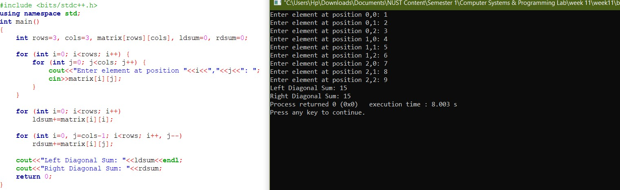

**TASK 2**

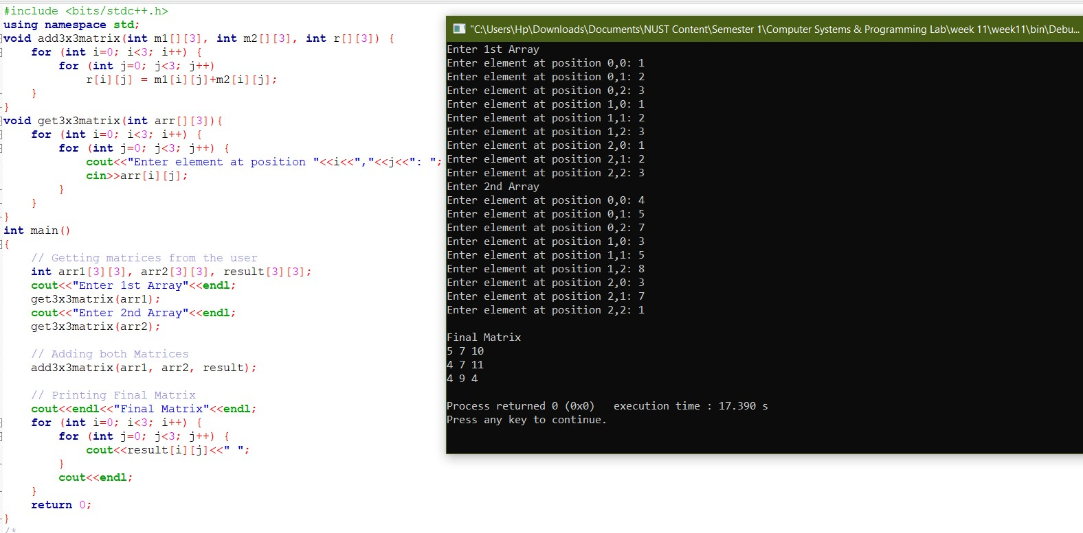

**TASK 3**

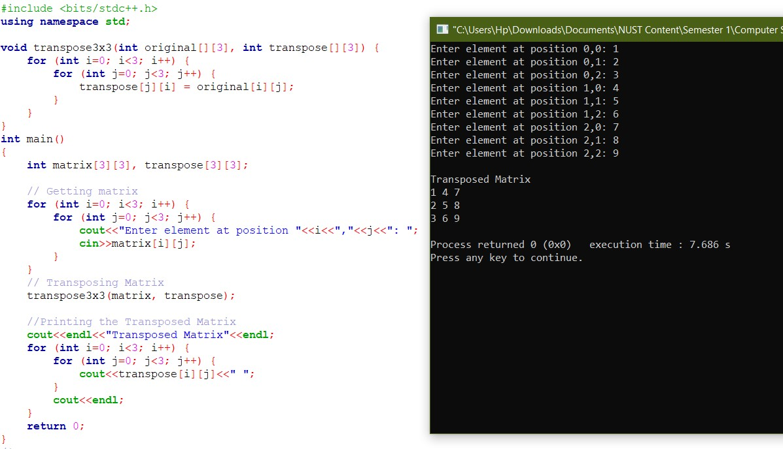

**TASK 4**

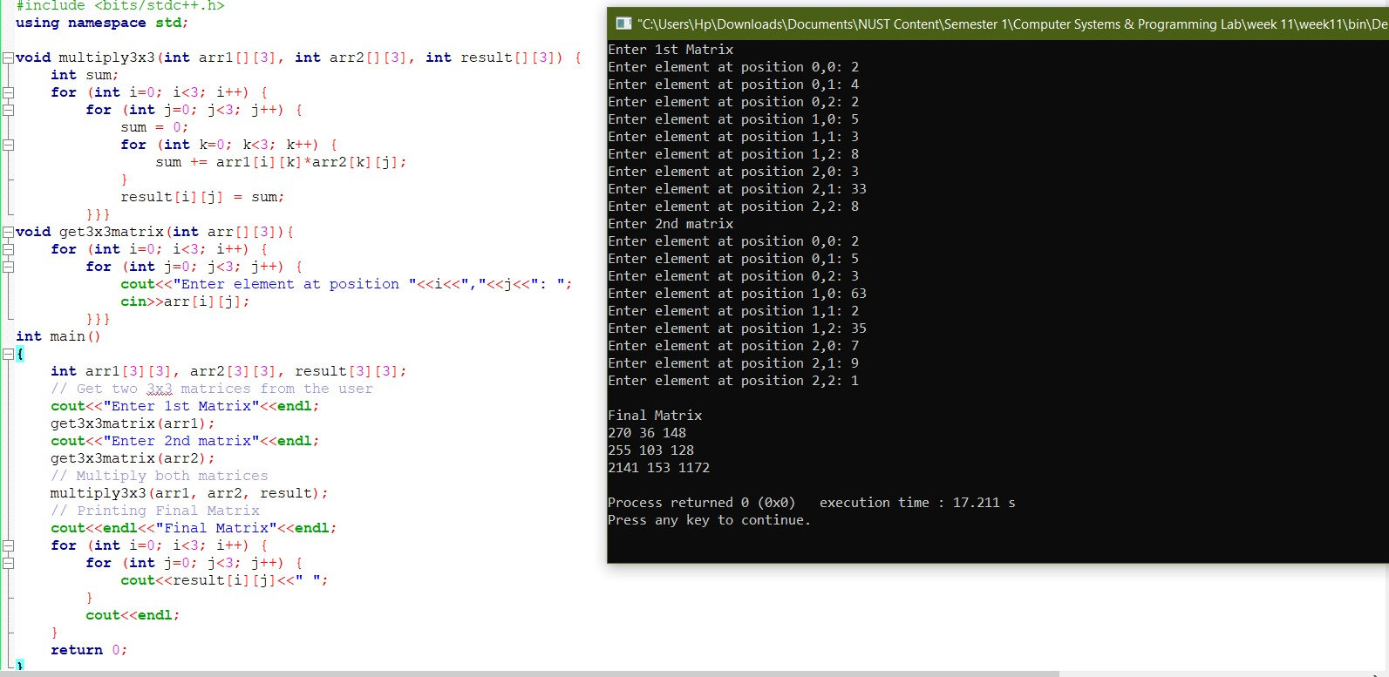

**TASK 5**

